Assignment 2

The design of the TechSupport database
The TechSupport database is used to track technical support incidents for a small software company. It consists of the six tables shown in the diagram that follows. The main table is the Incidents table, which contains one row for each technical support incident. Each row in the Incidents table is related to one row in the Customers table, which contains information about the company’s customers; one row in the Products table, which contains information about the company’s products; and one row in the Technicians table, which contains information about the company’s technical support staff. In addition, a table called Registrations keeps track of products that are registered to each customer, and the States table contains state and zip code information.

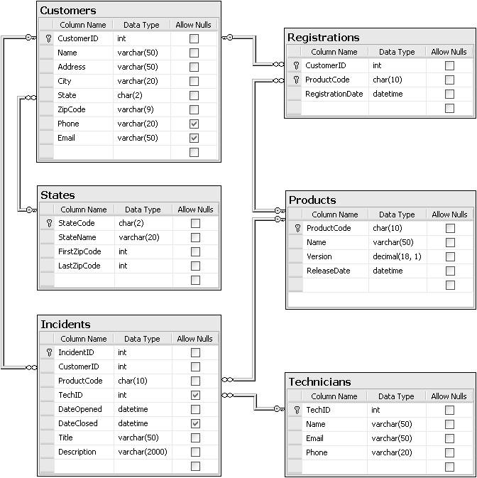
In addition to the column properties shown above, you should know that the CustomerID, IncidentID, and TechID columns in the Customers, Incidents, and Technicians tables are identity columns. So the values of these columns are set automatically when new rows are added to these tables.
Part A: Display Open Incidents
For this project, you’ll enhance the SportsPro application by adding a form that displays all open incidents in a ListView control. To do that, you’ll write code to create the connection, command, and data reader objects needed to retrieve the open incidents. This code will be stored in a class library within the same solution as the SportsPro project. (Required reading: chapter 6.)
The Open Incidents form
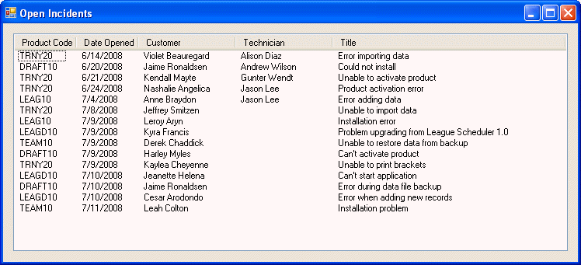
SportsPro project item
Name Description
frmOpenIncidents A form that displays open incidents in a ListView control.
TechSupportData project items
Name Description
Incident A business class that represents a single incident.
TechSupportDB A database class that contains a method that returns a connection object for the TechSupport database.
IncidentDB A database class that contains methods for working with the Incidents table in the TechSupport database.
CustomerDB A database class that contains methods for working with the Customers table in the TechSupport database.
TechnicianDB A database class that contains methods for working with the Technicians table in the TechSupport database.
Operation
- The Open Incidents form should be displayed when the user chooses the Incidents→Display Open Incidents command from the menu on the main form.
Specifications
- Create the TechSupportData class library, and add the classes required by this project to the library. Include the appropriate error handling code in these classes. Any exceptions that occur in the database classes should be thrown to the calling method and ultimately caught by the form class.
- To get the incident data, use a command with a Select statement that retrieves the appropriate data from the Incidents table. Then, use a data reader to read the rows that are returned.
- To get the names of the customer and the technician for an incident, use commands with a Select statement that returns a scalar value.
- To format the ListView control so you can display detail columns, set the View property of the control to Details and use the Columns collection to define the column headings.
- When the form is loaded, the Load event handler should call the GetOpenIncidents method of the IncidentDB class to get the open incidents and then display them in the ListView control. If an exception occurs or no open incidents are found, display an appropriate message but do not close the form.
Tips
- To get the connection string for the TechSupport database, double-click the app.config file in the Solution Explorer to display it in the Text Editor window. Then, locate the connection string and copy it into the code for the TechSupportDB class.
- Because the TechID and DateClosed columns in the Incidents table can be null, the fields for these columns in the Incident class should be defined as nullable types. For example, the field for the TechID column should be declared like this:
private int? techID;
In addition, the properties for these fields must be coded so they provide for a null. For example, the property for the TechID column should be coded like this:
public int? TechID
{
get
{
if (techID.HasValue)
return techID;
else
return null;
}
set
{
techID = value;
}
}
Before you can use the classes in the TechSupportData class library, you must compile the library and add a reference to this library to the SportsPro project. You should also add a using statement for this library to the form class.
The design of the Incident class
The private fields that store the property values
private int incidentID;
private int customerID;
private string productCode;
private int? techID;
private DateTime dateOpened;
private DateTime? dateClosed;
private string title;
private string description;
The IncidentID property
public int IncidentID
Gets and sets the incident ID for the incident.
The CustomerID property
public int CustomerID
Gets and sets the customer ID for the incident.
The ProductCode property
public string ProductCode
Gets and sets the product code for the incident.
The TechID property
public int? TechID
Gets and sets the technician ID for the technician assigned to the incident. Null if a technician has not been assigned.
The DateOpened property
public DateTime DateOpened
Gets and sets the date the incident was created.
The DateClosed property
public DateTime? DateClosed
Gets and sets the date the incident was closed. Null if the incident is still open.
The Title property
public string Title
Gets and sets the title for the incident.
The Description property
public string Description
Gets and sets the description for the incident.
The CustomerName property
public string CustomerName
Gets the name of the customer associated with the incident using the GetCustomerName method of the CustomerDB class.
The TechnicianName property
public string TechnicianName
Gets the name of the technician associated with the incident using the GetTechnicianName method of the TechnicianDB class.
The design of the TechSupportDB class
The GetConnection method
public static SqlConnection GetConnection()
Returns a SqlConnection object that establishes a connection to the TechSupport database.
The design of the IncidentDB class
The GetOpenIncidents method
public static List<Incident> GetOpenIncidents()
Returns a List<Incident> object that contains one item for each open incident in the Incidents table.
The design of the CustomerDB class
The GetCustomerName method
public static string GetCustomerName(int customerID)
Returns a string that contains the name of the customer with the specified ID.
The design of the TechnicianDB class
The GetTechnicianName method
public static string GetTechnicianName(int techID)
Returns a string that contains the name of the technician with the specified ID.
SQL statements
Select statement to get the incident data
SELECT CustomerID, ProductCode, TechID, DateOpened, Title
FROM Incidents
WHERE DateClosed IS NULL
Select statement to get the customer name
SELECT Name
FROM Customers
WHERE CustomerID = customerID
Select statement to get the technician name
SELECT Name
FROM Technicians
WHERE TechID = techID

Part B: Create an incident
For this project, you’ll enhance the SportsPro application by adding a form that lets the user add a row to the Incidents table. To do that, you’ll write code to create the command and parameter objects needed to insert the Incidents row. (Required reading: chapters 6 and 7.)
The Create Incident form
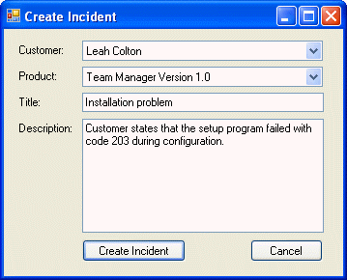
SportsPro project items
Name Description
frmCreateIncident A form that lets the user add a new incident to the Incidents table.
Validator A class that contains generic data validation methods.
TechSupportData project items
Name Description
Incident A business class that represents a single incident.
Customer A business class that represents a single customer.
Product A business class that represents a single product.
TechSupportDB A database class that contains a method that returns a connection object for the TechSupport database.
IncidentDB A database class that contains methods for working with the Incidents table in the TechSupport database.
CustomerDB A database class that contains methods for working with the Customers table in the TechSupport database.
ProductDB A database class that contains methods for working with the Products table in the TechSupport database.
RegistrationDB A database class that contains methods for working with the Registrations table in the TechSupport database.
Operation
- The Create Incident form should be displayed when the user chooses the Incidents→Create Incident command from the menu on the main form.
- To create an incident, the user selects the customer and product from the combo boxes, enters a title and description, and clicks the Create Incident button. If the incident is accepted, a confirmation message is displayed and the form is closed.
- To close the form without creating an incident, the user clicks the Cancel button.
Specifications
- To get the lists of customers and products that the combo boxes are bound to, use commands and data readers.
- Before creating a new incident, the program should check that the customer has registered the selected product and that the user has entered a title and description. If not, the program should display an error message.
- To determine if a product is registered to a customer, use a command with a parameterized query that returns a count of the number of rows for the specified customer and product.
- To add an incident to the Incidents table, use a command with parameters whose values are set to the properties of the Incident object. The DateOpened property of the Incident object should be set to the current date.
- This form is designed to create just one new incident. As a result, the form should be closed after a new incident is created.
The design of the Validator class
The IsPresent method
public static bool IsPresent(TextBox textBox, string name)
Returns a Boolean value that indicates if a text box contains a value. If not, an error message is displayed and the focus is set to the text box.
The design of the Incident class
The private fields that store the property values
private int incidentID;
private int customerID;
private string productCode;
private int? techID;
private DateTime dateOpened;
private DateTime? dateClosed;
private string title;
private string description;
The IncidentID property
public int IncidentID
Gets and sets the incident ID for the incident.
The CustomerID property
public int CustomerID
Gets and sets the customer ID for the incident.
The ProductCode property
public string ProductCode
Gets and sets the product code for the incident.
The TechID property
public int? TechID
Gets and sets the technician ID for the technician assigned to the incident. Null if a technician has not been assigned.
The DateOpened property
public DateTime DateOpened
Gets and sets the date the incident was created.
The DateClosed property
public DateTime? DateClosed
Gets and sets the date the incident was closed. Null if the incident is still open.
The Title property
public string Title
Gets and sets the title for the incident.
The Description property
public string Description
Gets and sets the description for the incident.
The design of the Customer class
The private fields that store the property values
private int customerID;
private string name;
The CustomerID property
public int CustomerID
Gets and sets the ID for the customer.
The Name property
public string Name
Gets and sets the name for the customer.
The design of the Product class
The private fields that store the property values
private string productCode;
private string name;
The ProductCode property
public string ProductCode
Gets and sets the product code that uniquely identifies the product.
The Name property
public string Name
Gets and sets the name for the product.
The design of the TechSupportDB class
The GetConnection method
public static SqlConnection GetConnection()
Returns a SqlConnection object that establishes a connection to the TechSupport database.
The design of the CustomerDB class
The GetCustomerList method
public static List<Customer> GetCustomerList()
Returns a List<Customer> object that contains one item for each customer in the Customers table.
The design of the ProductDB class
The GetProductList method
public static List<Product> GetProductList()
Returns a List<Product> object that contains one item for each product in the Products table.
The design of the IncidentDB class
The AddIncident method
public static void AddIncident(Incident incident)
Adds a row to the Incidents table.
The design of the RegistrationDB class
The ProductRegistered method
public static bool ProductRegistered(int customerID,
string productCode)
Returns a Boolean value that indicates if a product is registered to a customer.
SQL statements
Select statement to get the customer data
SELECT CustomerID, Name
FROM Customers
ORDER BY Name
Select statement to get the product data
SELECT ProductCode, Name
FROM Products
ORDER BY Name
Select statement to determine if a customer has registered a product
SELECT Count(*)
FROM Registrations
WHERE CustomerID = @CustomerID
AND ProductCode = @ProductCode
Insert statement to insert an incident
INSERT Incidents
(CustomerID, ProductCode, DateOpened, Title, Description)
VALUES (@CustomerID, @ProductCode, @DateOpened, @Title, @Description)

Part C: Display open incidents by technician
For this project, you’ll enhance the SportsPro application by adding a form that displays the open incidents for a selected technician. To do that, you’ll use two object data sources. (Required reading: chapters 6, 7, and 9.)
The Open Incidents by Technician form
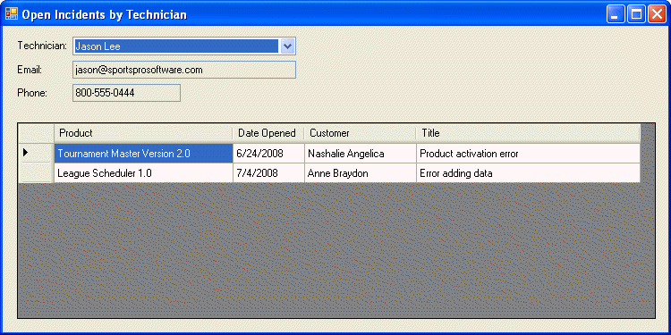
SportsPro project item
Name Description
frmTechnicianIncidents A form that lets the user display the open incidents for a technician.
TechSupportData project items
Name Description
Technician A business class that represents a single technician.
Incident A business class that represents a single incident.
TechSupportDB A database class that contains a method that returns a connection object for the TechSupport database.
TechnicianDB A database class that contains methods for working with the Technicians table in the TechSupport database.
IncidentDB A database class that contains methods for working with the Incidents table in the TechSupport database.
ProductDB A database class that contains methods for working with the Products table in the TechSupport database.
CustomerDB A database class that contains methods for working with the Customers table in the TechSupport database.
Operation
- The Open Incidents by Technician form should be displayed when the user chooses the Incidents→Display Open Incidents by Technician command from the menu on the main form.
- To display the open incidents for a technician, the user selects the technician from the combo box. In addition to the incidents, contact information for the selected technician is displayed on the form.
Specifications
- The combo box and the two text boxes on this form should be bound to an object data source that’s created from the Technician class. The DataGridView control should be bound to an object data source that’s created from the Incident class.
- When this form is first displayed, the first technician should be selected and the data for that technician should be displayed on the form.
The design of the Incident class
The private fields that store the property values
private int incidentID;
private int customerID;
private string productCode;
private int? techID;
private DateTime dateOpened;
private DateTime? dateClosed;
private string title;
private string description;
The IncidentID property
public int IncidentID
Gets and sets the incident ID for the incident.
The CustomerID property
public int CustomerID
Gets and sets the customer ID for the incident.
The ProductCode property
public string ProductCode
Gets and sets the product code for the incident.
The TechID property
public int? TechID
Gets and sets the technician ID for the technician assigned to the incident. Null if a technician has not been assigned.
The DateOpened property
public DateTime DateOpened
Gets and sets the date the incident was created.
The DateClosed property
public DateTime? DateClosed
Gets and sets the date the incident was closed. Null if the incident is still open.
The Title property
public string Title
Gets and sets the title for the incident.
The Description property
public string Description
Gets and sets the description for the incident.
The CustomerName property
public string CustomerName
Gets the name of the customer associated with the incident using the GetCustomerName method of the CustomerDB class.
The ProductName property
public string ProductName
Gets the name of the product associated with the incident using the GetProductName method of the ProductDB class.
The design of the Technician class
The private fields that store the property values
private int techID;
private string name;
private string email;
private string phone;
The TechID property
public int TechID
Gets and sets the ID for the technician.
The Name property
public string Name
Gets and sets the name for the technician.
The Email property
public string Email
Gets and sets the email address for the technician.
The Phone property
public string Phone
Gets and sets the phone number for the technician.
The design of the TechSupportDB class
The GetConnection method
public static SqlConnection GetConnection()
Returns a SqlConnection object that establishes a connection to the TechSupport database.
The design of the TechnicianDB class
The GetTechnicianList method
public static List<Technician> GetTechnicianList()
Returns a List<Technician> object that contains one item for each technician in the Technicians table.
The GetTechnician method
public static Technician GetTechnician(int techID)
Returns a Technician object for the technician with the specified ID.
The design of the IncidentDB class
The GetOpenTechnicianIncidents method
public static List<Incident> GetOpenTechnicianIncidents(int techID)
Returns a List<Incident> object that contains one item for each open incident for the technician with the specified ID.
The design of the ProductDB class
The GetProductName method
public static string GetProductName(string productCode)
Returns a string that contains the name of the product with the specified product code.
The design of the CustomerDB class
The GetCustomerName method
public static string GetCustomerName(int customerID)
Returns a string that contains the name of the customer with the specified ID.
SQL statements
Select statement to get the list of technicians
SELECT TechID, Name
FROM Technicians
ORDER BY Name
Select statement to get the data for a specified technician
SELECT TechID, Name, Email, Phone
FROM Technicians
WHERE TechID = @TechID
Select statement to get the open incidents for a specified technician
SELECT CustomerID, ProductCode, DateOpened, Title
FROM Incidents
WHERE TechID = @TechID
AND DateClosed IS NULL
Select statement to get the product name
SELECT Name
FROM Products
WHERE ProductCode = @ProductCode
Select statement to get the customer name
SELECT Name
FROM Customers
WHERE CustomerID = customerID

Submitting your assignment

This project is to be done independently. To submit your assignment:
- Create a zip file containing your entire project (using Windows, Winzip or Winrar)
- Name this zip file using your full name
- Email the file to d1lee@ryerson.ca with the subject line:
CXEC 305 – A2
- You must submit your assignment before the due date. The timestamp of the electronic submission will determine if you have met the deadline.

If you find that there is a problem with your submission and must resubmit it, please use an alternate filename extension, (e.g, joesmithV2.zip) and email it with an alternate subject line (e.g., CXEC 305 – A2 v2).

It is your responsibility to submit a file that is working properly!

